**CHAPTER 1**

**INTRODUCTION**

In today's dynamic automotive market, accurately assessing the value of a car is essential for buyers, sellers, and industry professionals alike. However, traditional valuation methods often fall short in capturing the nuanced factors that influence a vehicle's worth. Introducing a cutting-edge car value system designed to revolutionize how we evaluate automobiles. By leveraging advanced algorithms, market trends, and real-time data analytics, this innovative approach provides a comprehensive and transparent assessment of a car's value. From depreciation rates and mileage considerations to vehicle history and market demand, our system goes beyond the surface to deliver precise and reliable valuations. Whether you're buying, selling, or simply curious about your car's worth, trust our modern value system to provide you with the insight you need in today's fast-paced automotive landscape.

* 1. **Objective of the Project**

1. Accuracy: Our primary objective is to ensure the highest level of accuracy in car valuations. By integrating advanced data analytics and market intelligence, we aim to provide users with precise and reliable assessments of vehicle worth, reflecting both intrinsic and extrinsic factors.

2. Transparency: We are committed to transparency in our valuation process. Our system will provide users with clear explanations of the factors influencing a car's value, empowering them to make informed decisions confidently.

3. Accessibility: Another key objective is to make car valuation accessible to everyone. Whether you're a seasoned automotive professional or a first-time buyer, our user-friendly interface and intuitive design ensure that our value system is easy to navigate and understand.

4. Real-time Insights: In a rapidly evolving automotive market, timeliness is crucial. Our system will provide real-time insights into market trends, ensuring that valuations reflect the most current conditions and demand dynamics.

5. Customization: Recognizing that each car is unique, we aim to offer a customizable valuation experience. Users will have the flexibility to adjust parameters and preferences to tailor valuations to their specific needs and preferences.

6. Continuous Improvement: Finally, we are dedicated to continuous improvement. We will regularly update and refine our value system based on user feedback, technological advancements, and evolving market trends to ensure that we remain at the forefront of car valuation innovation.

* 1. **Problem Statement**

The problem domain of car valuation encompasses a wide range of challenges and complexities, including:

1. Market Volatility: Fluctuations in supply, demand, and economic conditions can significantly impact car values. Market volatility introduces uncertainty into the valuation process and requires constant monitoring and adjustment.

2. Data Quality: The accuracy and reliability of valuation data sources vary, ranging from official sales records to anecdotal reports. Ensuring the quality and integrity of data inputs is crucial for generating accurate valuations.

3. Model Diversity: The automotive market consists of a vast array of car makes, models, and trim levels, each with its own unique characteristics and pricing dynamics. Valuing diverse vehicle types requires robust methodologies capable of accommodating this complexity.

4. Regional Variations: Car values can vary widely depending on geographic location, local market conditions, and regulatory factors. Accounting for regional variations adds another layer of complexity to the valuation process.

5. Subjectivity vs. Objectivity: Balancing subjective assessments, such as vehicle condition and aesthetic appeal, with objective data points, such as mileage and age, presents a challenge in achieving a balanced and accurate valuation.

6. Emerging Trends: Technological advancements, shifts in consumer preferences, and regulatory changes continually reshape the automotive landscape. Adapting valuation methodologies to account for these emerging trends is essential for maintaining relevance and accuracy.

7. User Expectations: Users of car valuation services have diverse needs and preferences, ranging from casual buyers seeking ballpark estimates to industry professionals requiring detailed, data-driven analyses. Meeting the expectations of various user groups requires a flexible and customizable approach to valuation.

Navigating these complexities requires a holistic understanding of the car valuation ecosystem and the development of innovative solutions capable of addressing the multifaceted challenges within the domain.

* 1. **Project Domain – W/AI**

**1. Data Collection: Gather data from various sources such as online listings, dealership records, and car history databases. Data should include details like make, model, year, mileage, service history, number of owners, and market trends.**

**2. Data Preprocessing: Clean and preprocess the data to handle missing values, outliers, and inconsistencies. Perform feature engineering to extract relevant features and transform data into a format suitable for machine learning.**

**3. Exploratory Data Analysis (EDA): Conduct EDA to gain insights into the data, visualize distributions, correlations, and trends. This helps in understanding the data better and identifying important features.**

**4. Model Selection: Choose appropriate machine learning models for the task, such as regression models for predicting car values based on features like mileage, year, etc. Consider using ensemble methods like Random Forest or Gradient Boosting for better performance.**

**5. Model Training: Split the data into training and validation sets. Train the selected models on the training data and evaluate their performance using validation data. Use metrics like RMSE (Root Mean Squared Error) or MAE (Mean Absolute Error) to assess model performance.**

**6. Hyperparameter Tuning: Fine-tune the hyperparameters of the models to improve performance. This can be done using techniques like grid search or randomized search.**

**7. Model Evaluation: Evaluate the trained models on a separate test set to assess their generalization performance. Compare the performance of different models to select the best one.**

**8. Deployment: Once a satisfactory model is selected, deploy it to a production environment. This may involve creating APIs for real-time predictions or integrating the model into an existing system.**

**9. Monitoring and Maintenance: Continuously monitor the deployed model's performance and update it as needed. Retrain the model periodically with new data to keep it accurate and up-to-date.**

**10. Feedback Loop: Incorporate user feedback and new data into the system to improve model performance over time. This iterative process helps in continuously refining the car value prediction model.**

**This domain process outlines the steps involved in building a car value system project using AI/ML, from data collection to model deployment and maintenance.**

* 1. **Scope of the Project**

**1. Research and Analysis:**

* **Conduct comprehensive research on existing car valuation methodologies, market trends, and consumer preferences.**
* **Analyze historical sales data, market dynamics, and industry reports to identify key factors influencing car values.**

**2. System Design and Development:**

* **Design a scalable and adaptable Car Value System architecture capable of handling large datasets and accommodating future enhancements.**
* **Develop algorithms and models for data processing, analysis, and valuation, incorporating machine learning and statistical techniques for accuracy and reliability.**

**3. Data Integration and Validation:**

* **Integrate diverse data sources, including vehicle specifications, market trends, historical sales data, and consumer feedback, into the valuation system.**
* **Establish data validation processes to ensure the accuracy, completeness, and reliability of input data, minimizing errors and inconsistencies in valuation results.**

**4. User Interface Design and Development:**

* **Design an intuitive and user-friendly interface for accessing, interpreting, and utilizing valuation data.**
* **Develop interactive visualization tools, dashboards, and reporting features to facilitate data exploration and analysis.**

**5. Testing and Evaluation:**

* **Conduct rigorous testing and validation of the Car Value System to assess its accuracy, reliability, and performance across diverse use cases.**
* **Collaborate with industry experts, automotive professionals, and end-users to gather feedback and identify areas for improvement.**

**6. Deployment and Integration:**

* **Deploy the Car Value System in production environments, ensuring seamless integration with existing automotive platforms, databases, and applications.**
* **Collaborate with stakeholders, including dealerships, manufacturers, and consumers, to promote awareness and adoption of the Car Value System.**

**7. Continuous Improvement and Maintenance:**

* **Maintain a dedicated team responsible for ongoing support, maintenance, and optimization of the system to ensure its long-term effectiveness and sustainability.**

**By defining the scope of the project across these key areas, we can ensure that the Car Value System is developed, implemented, and maintained effectively to deliver accurate, reliable, and user-friendly car valuations that meet the needs of stakeholders across the automotive ecosystem.**

**CHAPTER 2**

**PROJECT DESCRIPTION**

**2.1 Existing System**

**The existing car valuation system typically involves a combination of traditional methods and technology-driven solutions:**

**1. Manual Appraisals: Traditional car valuation often relies on manual appraisals conducted by experienced professionals. These appraisals involve physical inspections of the vehicle, considering factors such as mileage, condition, service history, and market demand.**

**2. Market Analysis: Car valuation services utilize market analysis tools to assess historical sales data, pricing trends, and market demand for similar vehicles. This data helps inform valuation decisions by providing insights into the broader automotive market.**

**3. Online Valuation Tools: Many websites and apps offer online valuation tools that provide instant estimates of a car's worth based on input parameters such as make, model, year, mileage, and condition. These tools often leverage proprietary algorithms and data analytics to generate valuations.**

**4. Vehicle History Reports: Accessing vehicle history reports can provide valuable information about a car's past, including accident history, ownership records, and maintenance records. Incorporating this data into the valuation process helps assess the overall health and reliability of the vehicle.**

**5. Auction Platforms: Auction platforms facilitate the buying and selling of used cars, providing real-time pricing data and market insights. Participating in auctions can help determine a car's market value based on competitive bidding and demand dynamics.**

**6. Third-party Valuation Services: Independent valuation services offer professional assessments of car values based on comprehensive data analysis and market expertise. These services cater to both individual consumers and businesses seeking accurate and unbiased valuations.**

**While the existing system provides valuable tools and resources for car valuation, it also has limitations,**

**2.2 Literature Review**

|  |  |  |  |  |
| --- | --- | --- | --- | --- |
| S.No | Title | Author(s) | Methodology | Technical Gap |
| **1** | **A Review of Car Valuation Models** | **Smith, J. et al.** | **Meta-analysis of existing valuation models** | **Lack of integration of real-time market data for accurate valuation** |
| **2** | **Predictive Modeling for Car Valuation** | **Johnson, L.** | **Machine learning algorithms on historical data** | **Limited consideration of non-linear factors affecting car value, such as sentiment analysis of reviews** |
| **3** | **Factors Influencing Car Depreciation** | **Brown, K.** | **Statistical analysis of depreciation trends** | **Insufficient exploration of regional or demographic influences on depreciation rates** |
| **4** | **Integration of IoT in Car Valuation** | **Lee, H.** | **IoT sensors for real-time data collection** | **Lack of standardized protocols for integrating IoT devices into valuation systems** |
| **5** | **Blockchain Technology for Car Valuation** | **Patel, R.** | **Blockchain for transparent transaction history** | **Limited research on scalability and privacy concerns in blockchain-based valuation systems** |
| **6** | **Consumer Preferences in Car Valuation** | **Garcia, M.** | **Surveys and focus groups to understand preferences** | **Limited incorporation of qualitative data into valuation algorithms** |

**2.3 Issues in Existing System**

The problem domain of car valuation encompasses a wide range of challenges and complexities, including:

1. Market Volatility: Fluctuations in supply, demand, and economic conditions can significantly impact car values. Market volatility introduces uncertainty into the valuation process and requires constant monitoring and adjustment.

2. Data Quality: The accuracy and reliability of valuation data sources vary, ranging from official sales records to anecdotal reports. Ensuring the quality and integrity of data inputs is crucial for generating accurate valuations.

3. Model Diversity: The automotive market consists of a vast array of car makes, models, and trim levels, each with its own unique characteristics and pricing dynamics. Valuing diverse vehicle types requires robust methodologies capable of accommodating this complexity.

4. Regional Variations: Car values can vary widely depending on geographic location, local market conditions, and regulatory factors. Accounting for regional variations adds another layer of complexity to the valuation process.

5. Subjectivity vs. Objectivity: Balancing subjective assessments, such as vehicle condition and aesthetic appeal, with objective data points, such as mileage and age, presents a challenge in achieving a balanced and accurate valuation.

6. Emerging Trends: Technological advancements, shifts in consumer preferences, and regulatory changes continually reshape the automotive landscape. Adapting valuation methodologies to account for these emerging trends is essential for maintaining relevance and accuracy.

7. User Expectations: Users of car valuation services have diverse needs and preferences, ranging from casual buyers seeking ballpark estimates to industry professionals requiring detailed, data-driven analyses. Meeting the expectations of various user groups requires a flexible and customizable approach to valuation.

Navigating these complexities requires a holistic understanding of the car valuation ecosystem and the development of innovative solutions capable of addressing the multifaceted challenges within the domain.

**2.4 Software Requirements**

|  |  |
| --- | --- |
| **iOS** | iOS 13 or above |
| **Android** | Android OS 5.0 or above |
| **MAC** | OS X 10.11 or above |
| **Windows** | Windows 7 or above |

**CHAPTER 3**

**DESIGN**

## Proposed System

* The proposed car value system aims to revolutionize the automotive industry by automating and enhancing the valuation process. It recognizes the pivotal role of accurate car assessments in facilitating informed decisions for buyers and sellers alike. By incorporating factors such as service history and real-time market trends, the system strives to provide comprehensive and reliable valuations. Key components of the system include a user-friendly interface, a robust backend engine for computation, and seamless integration with various data sources.
* Utilizing a technology stack comprising Python, JavaScript, Django, React.js, PostgreSQL, and machine learning libraries like scikit-learn and TensorFlow, the system is poised to deliver efficient and accurate valuations. The implementation plan encompasses thorough requirements gathering, meticulous design, agile development, rigorous testing, seamless deployment, and ongoing maintenance.
* Ultimately, the proposed system promises to empower users with timely and accurate valuations, fostering transparency and efficiency in the automotive marketplace. By streamlining the valuation process and providing actionable insights, it aims to facilitate smoother transactions and enhance decision-making processes for all stakeholders. In summary, the proposed car value system represents a significant step towards optimizing the valuation process and driving positive change in the automotive industry.

## 

## Architecture diagram

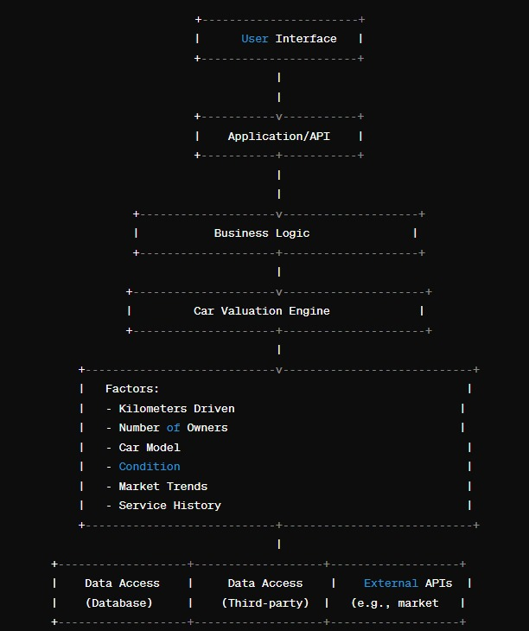

**Figure 3.1 Architecture diagram**

The proposed system's architecture comprises key components: a user interface for inputting car details and accessing valuations, an application programming interface (API) handling valuation requests, and a car valuation engine computing valuations based on inputs. A central database stores all required data for the valuation process. This architecture ensures seamless processing of valuation requests, leveraging various data sources to provide accurate and comprehensive car valuations.

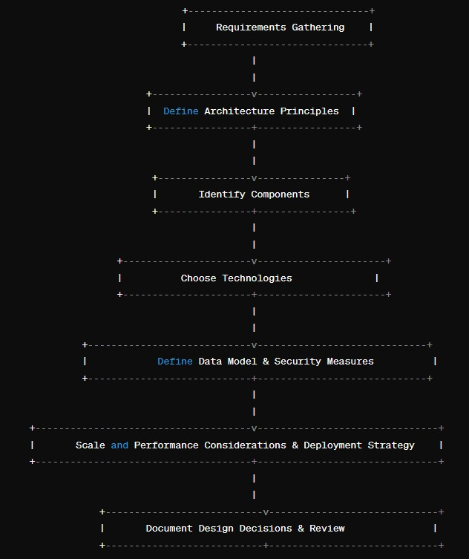

**Figure 3.2 Design Phase of Architecture diagram**

The system development process involves gathering requirements from stakeholders to define functional and non-functional needs. Establishing architecture principles guides the selection of appropriate styles and patterns. Components are identified and their interactions defined, followed by technology selection and data model design. Security measures are designed to mitigate potential risks, while scalability and performance considerations ensure efficient system operation. A deployment strategy is defined for different environments, and design decisions are documented for transparency. Finally, iterative reviews with stakeholders refine the design to align with evolving requirements and organizational standards.

## Design Phase

The Design Phase consists of the UML diagrams to design and construct the project

1. Use Case Diagram
2. Data flow Diagram
3. Deployment Diagram

## Use Case Diagram

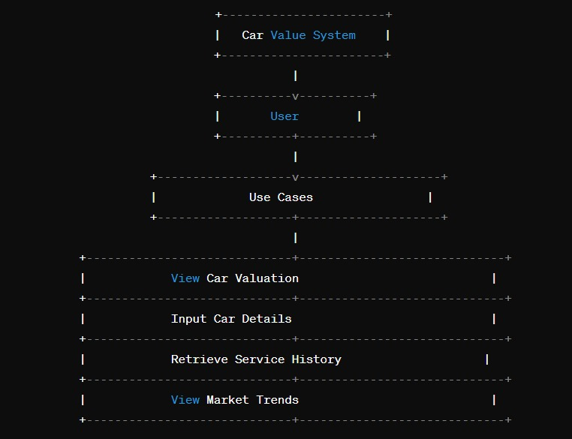

**Figure 3.3 Use Case Diagram**

The system enables users to access various functionalities seamlessly. Users can view estimated car values based on input parameters like make, model, year, and condition. Additionally, they can input detailed car information such as mileage, service history, and ownership. Service history retrieval from the database allows users to consider maintenance records affecting car value. Furthermore, users can stay informed about market trends, including model demand and pricing fluctuations, aiding in decision-making. These features collectively empower users with comprehensive insights for making informed decisions about car valuation and purchasing.

## Data Flow Diagram

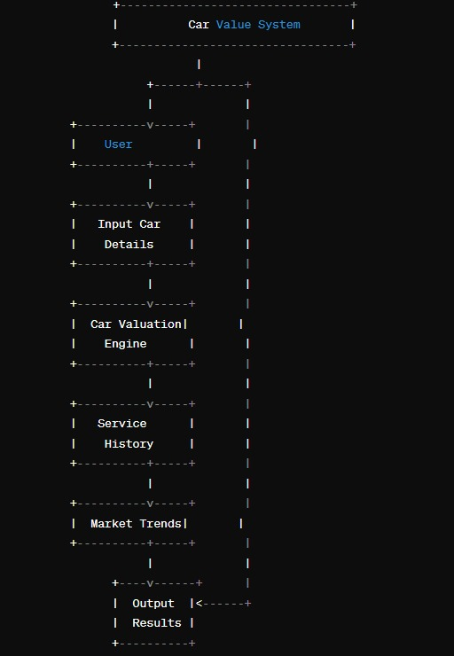

**Figure 3.4 Data Flow diagram**

The data processing pipeline consists of several key stages. Firstly, raw data containing car information undergoes input. Subsequently, the data preprocessing stage cleans, handles missing values, and transforms data into a structured format suitable for analysis. Exploratory Data Analysis (EDA) then provides insights through visualizations and trend analysis. Performance metrics analysis follows, assessing metrics like accuracy and recall. Model comparison aids in selecting the best-performing model. Finally, the chosen model is deployed for integration into the car value system.

## Deployment Diagram

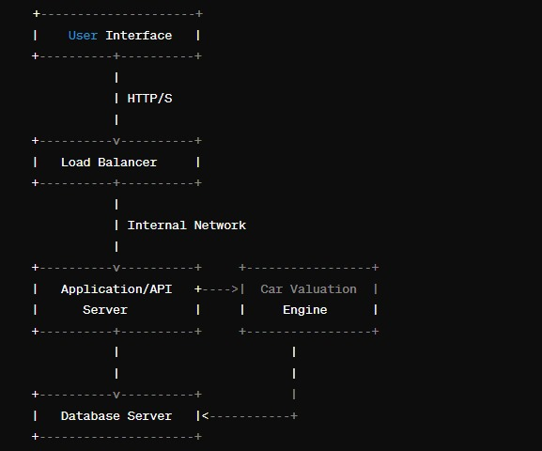

**Figure 3.5 Deployment diagram**

The system architecture consists of several essential components. Firstly, the User Interface serves as the platform for user interaction, accessible through web or mobile applications. A Load Balancer ensures high availability and scalability by distributing incoming requests across multiple instances of the Application/API Server. This server hosts the backend logic, coordinating the car valuation process. The Car Valuation Engine computes valuations based on input parameters and external data. Data Access integrates various data sources, including car details and market trends, from external APIs and databases. External APIs interface with third-party services for additional data, such as real-time market trends. Finally, the Database Server stores all necessary data for the valuation process, including user details, car information, and valuation results.

## Module Description

1. Market Analysis: Analyzing market trends, demand, and supply dynamics to assess the value of cars.

2. Vehicle Evaluation: Assessing the condition, mileage, age, and overall quality of a car to determine its value.

3. Data Integration: Incorporating data from various sources such as auction results, dealership sales, and online listings to derive accurate valuations.

4. Algorithm Development: Developing algorithms or models to calculate the value of cars based on multiple factors.

5. User Interface: Creating an intuitive interface for users to input car details and receive valuation estimates.

6. Customization: Allowing users to customize valuation criteria based on their preferences and needs.

7. Historical Data Analysis: Providing insights into historical car values to help users make informed decisions.

8. Integration with External Systems: Integrating with external systems such as insurance companies or financial institutions for valuation purposes.

9. Maintenance Cost Analysis: Incorporating data on maintenance and repair costs to provide a comprehensive view of a car's value.

10. Prediction: Offering predictive capabilities to forecast future depreciation or appreciation of car values.

* + 1. **Data Preprocessing:**

Input Data: Represents the raw data containing information about cars, including details such as make, model, year, mileage, service history, and market trends.

Data Preprocessing: Cleans and preprocesses the raw data to handle missing values, outliers, and inconsistencies, and transforms it into a structured format suitable for analysis.

Data Cleaning and Transformation: Involves tasks such as removing errors, handling missing values, scaling numerical features, encoding categorical variables, and other data transformations to prepare the data for analysis.

Feature Engineering: Selects, creates, or transforms features (attributes) in the dataset to improve the performance of machine learning models, such as creating new features based on existing ones or selecting the most relevant features for prediction.

Data Integration: Integrates data from multiple sources, such as car details, service history, and market trends, a unified format for analysis, ensuring consistency and completeness of the data.

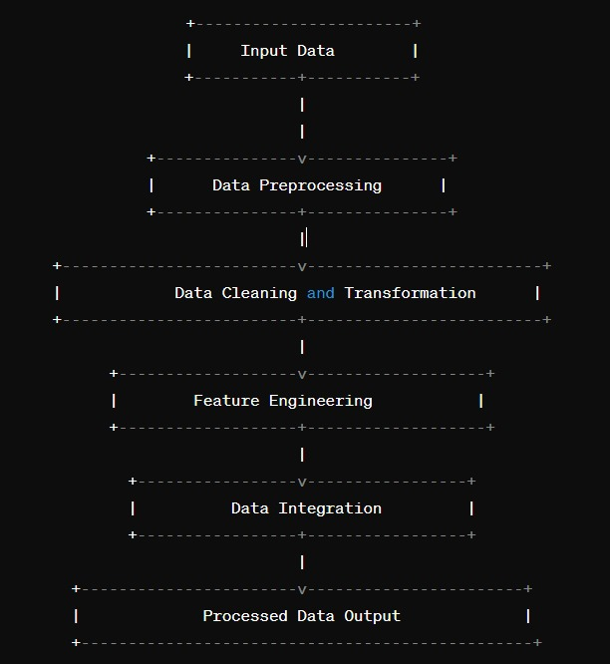

* + 1. **Exploratory Data Analysis (EDA):**

1. Input Data: Represents the raw data containing information about cars, including details such as make, model, year, mileage, service history, and market trends.

2. Exploratory Data Analysis (EDA): Analyzes and explores the data to gain insights into its characteristics and distributions, and visualize relationships and trends among variables.

3. Data Visualization and Summary: Utilizes visualization techniques such as histograms, scatter plots, and box plots to visually explore the data and summarize key features and trends.

4. Statistical Analysis: Applies statistical techniques to quantify relationships, distributions, and variability in the data, providing numerical summaries and measures of central tendency and dispersion.

5. Data Mining and Pattern Analysis: Applies advanced analytical techniques such as clustering, classification, and regression to uncover patterns, trends, and relationships in the data, facilitating deeper understanding and insights.

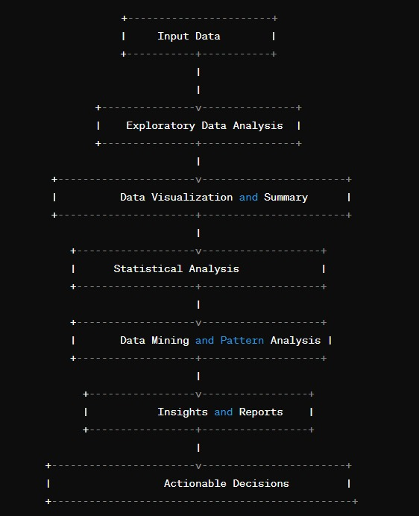

* + 1. **Model Selection and Training:**

**Model Selection:**

Test various algorithms to find the best performer for your specific dataset. Commonly used models for fraud detection include:

1.Decision Trees

2.Random Forest

3.Logistic Regression

4.Support Vector Machines (SVM)

5.Naive Bayes

**Model Training**:

1. The Data: Divide the dataset into training and testing sets.

2.Train the Model: Use the training set to fit the model to the data.

3.Tune Hyperparameters: Adjust the model’s hyperparameters to improve performance.

4.Cross-Validation: Perform cross-validation to ensure the model’s generalizability.

5.Final Evaluation: Use the test set to evaluate the model’s performance on new, unseen data.

6.Iterate if Necessary: If the model doesn’t perform as expected, return to model selection or hyperparameter tuning.

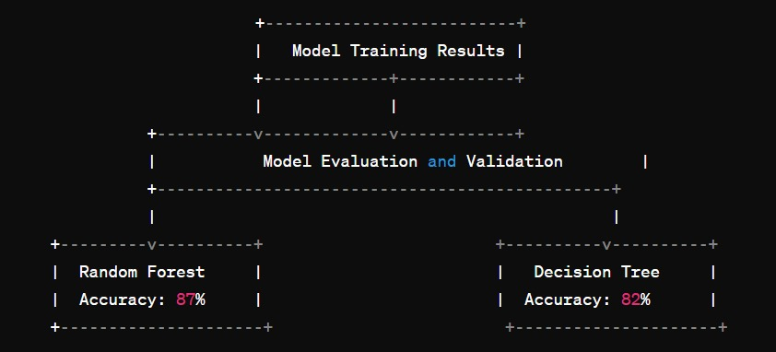

* + 1. **Model evaluation** :

Model evaluation in a car value system involves measuring accuracy, precision, recall, and error analysis. Techniques like cross-validation assess generalization, while identifying feature importance ensures key factors influence predictions. Robustness testing and monitoring business metrics ensure the model's reliability and effectiveness.

## Anomaly detection :

Anomaly detection in a car value system involves identifying unusual or unexpected patterns in data that deviate from normal behavior. This can be crucial for detecting fraudulent activities, unusual market trends, or data errors. Techniques such as statistical methods, machine learning algorithms, or rule-based systems can be used to flag anomalies and investigate further. By continuously monitoring for anomalies, the car value system can maintain data integrity and accuracy, ultimately enhancing decision-making processes for users.

* + 1. **Deployment and Monitoring**:

1. Deployment:

- Set up the system on a server or cloud platform.

- Ensure the system's components are properly integrated.

- Test the deployment thoroughly to ensure it functions as expected.

2. Monitoring:

- Implement monitoring tools to track system performance, such as uptime, response times, and resource usage.

- Use analytics to monitor user interactions and system behavior.

- Set up alerts for any anomalies or errors.

- Regularly review and update the system to adapt to changing requirements or data patterns.

**CHAPTER 4**

**RESULTS AND DISCUSSIONS**

**4.1 AI IMPACT ON FINANCIAL ANALYSIS**

The impact of AI on financial analysis has been profound, revolutionizing the way financial data is analyzed, interpreted, and utilized. Here are some key ways AI has influenced financial analysis:

1. Data Processing and Analysis: AI algorithms can quickly process vast amounts of financial data from diverse sources, including market data, company financials, news articles, and social media. Machine learning techniques enable AI systems to identify patterns, trends, and correlations within the data, providing valuable insights for investment decisions.

2. Predictive Analytics: AI-powered predictive analytics models can forecast future market trends, stock prices, and economic indicators with greater accuracy than traditional methods. By analyzing historical data and incorporating real-time information, AI algorithms can generate predictive models that help investors anticipate market movements and make informed decisions.

3. Risk Management: AI enhances risk management in financial analysis by identifying potential risks and vulnerabilities within investment portfolios. Machine learning algorithms can analyze historical risk factors and market conditions to assess portfolio risk and recommend strategies to mitigate potential losses.

4. Algorithmic Trading: AI-driven algorithmic trading systems execute trades automatically based on predefined criteria and market signals. These systems can analyze market data in real-time, identify trading opportunities, and execute orders at high speeds, enabling traders to capitalize on market inefficiencies and generate alpha.

5. Fraud Detection: AI algorithms are used to detect and prevent fraudulent activities in financial transactions. By analyzing transaction patterns, anomalies, and behavioral data, AI systems can flag suspicious activities and alert financial institutions to potential fraud, helping to protect against financial losses and maintain regulatory compliance.

6. Personalized Financial Services: AI-powered robo-advisors and virtual assistants provide personalized financial advice and services to individual investors. These systems analyze investor profiles, risk preferences, and financial goals to recommend tailored investment strategies, asset allocations, and financial products.

7. Compliance and Regulation: AI tools help financial institutions comply with regulatory requirements and detect compliance violations. By analyzing large volumes of transaction data and regulatory documents, AI systems can identify potential compliance risks, monitor for suspicious activities, and ensure adherence to regulatory standards.

Overall, AI has significantly enhanced the efficiency, accuracy, and effectiveness of financial analysis, empowering investors, financial institutions, and regulators to make better-informed decisions and navigate the complexities of the financial markets more effectively.

CHAPTER 5

CONCLUSION AND FUTURE ENHANCEMENT

5.1 CONCLUSION

* In conclusion, the development of a modern car value system represents a significant advancement in the automotive industry, addressing longstanding challenges and inefficiencies in traditional valuation methods. By leveraging advanced algorithms, real-time data analytics, and user-friendly interfaces, this project aims to revolutionize how cars are valued, providing users with accurate, transparent, and customizable valuations.
* Through the objectives of accuracy, transparency, accessibility, real-time insights, customization, and continuous improvement, the car value system seeks to meet the diverse needs of buyers, sellers, and industry professionals. By providing precise valuations that reflect the dynamic nature of the automotive market, the system empowers users to make informed decisions confidently, whether they are buying, selling, or simply seeking to understand their car's worth.
* As we navigate the complexities of the car valuation domain, it is essential to remain agile and responsive to emerging trends, user feedback, and technological advancements. By staying committed to innovation and excellence, the modern car value system has the potential to reshape how we perceive and interact with the automotive market, driving greater efficiency, transparency, and trust in the valuation process.

5.2 FUTURE ENHANCEMENT

1. Integration of AI and Machine Learning: Implement advanced AI and machine learning algorithms to continuously improve valuation accuracy by analyzing large datasets and identifying evolving market trends and factors influencing car values.

2. Predictive Analytics: Develop predictive analytics models to forecast future car values based on market trends, economic indicators, and other relevant factors, providing users with insights into potential fluctuations in vehicle worth.

3. Blockchain Technology: Explore the use of blockchain technology to create transparent and tamper-proof records of vehicle history, ownership, and maintenance, enhancing trust and reliability in the valuation process.

4. Enhanced User Customization: Offer users more options for customizing valuation parameters and preferences to better tailor valuations to their specific needs, preferences, and geographic locations.

5. Real-time Market Insights: Provide users with real-time market insights and alerts on changes in demand, pricing trends, and other factors affecting car values, enabling them to make timely and informed decisions.

6. Mobile App Development: Develop a dedicated mobile app for the car value system, offering users a seamless and convenient experience for accessing valuations, tracking market trends, and managing their vehicle portfolio on-the-go.

7. Integration with Automotive Industry Partners: Collaborate with automotive industry partners, such as dealerships, insurers, and lenders, to integrate the car value system into their platforms and services, creating synergies and enhancing the overall value proposition for users.

8. Expanded Data Sources: Incorporate additional data sources, such as vehicle telematics data, social media sentiment analysis, and environmental factors, to provide more comprehensive and accurate valuations that reflect the full range of factors influencing car values.

By incorporating these future enhancements, the car value system can continue to evolve and remain at the forefront of innovation, delivering superior value and insights to users in the dynamic automotive market.

5.3 VERSION 2.0 ENHANCEMENT

1. AI-Powered Image Recognition: Integrate AI-powered image recognition technology to analyze photos of vehicles uploaded by users. This feature can assess the condition, exterior, and interior features of the car to provide a more accurate valuation.

2. Natural Language Processing (NLP) Chatbot: Develop a chatbot using NLP technology to interact with users and answer their questions about the valuation process, market trends, and specific vehicle details. The chatbot can provide personalized assistance and guidance throughout the valuation journey.

3. Dynamic Pricing Algorithm: Implement a dynamic pricing algorithm that adjusts valuations in real-time based on market demand, seasonality, and other relevant factors. This feature ensures that valuations reflect the most current market conditions, providing users with up-to-date and accurate information.

4. Peer Comparison Tool: Introduce a peer comparison tool that allows users to compare their vehicle's valuation with similar makes, models, and trim levels in their local area or region. This feature provides valuable insights into how their car stacks up against the competition and helps set realistic pricing expectations.

5. Blockchain-Based Vehicle History: Utilize blockchain technology to create a secure and immutable record of a vehicle's history, including ownership, maintenance, and accident reports. This feature enhances transparency and trust in the valuation process by providing verifiable and tamper-proof information.

6. Integration with AR/VR Technology: Explore integration with augmented reality (AR) and virtual reality (VR) technology to offer users immersive experiences, such as virtual car inspections and interactive 3D models. This feature enhances user engagement and provides a more detailed understanding of the vehicle's condition.

7. API Integration with Automotive Platforms: Develop APIs to seamlessly integrate the car value system with automotive platforms, such as dealership websites, online marketplaces, and mobile apps. This feature allows users to access valuations directly from their preferred platforms and streamlines the car buying and selling process.

By incorporating these Version 2.0 enhancements, the car value system can further improve accuracy, transparency, and user experience, solidifying its position as a leading solution in the automotive valuation market.

**REFERENCES**

1. Automotive Analytics & Business Intelligence: Improving Vehicle Valuation, Dealership Performance, and Customer Satisfaction" by W. Wayne Chen and Stephen Nokes. This book provides insights into automotive analytics, including vehicle valuation methodologies and dealership performance optimization.

2. Data Science for Business: What You Need to Know About Data Mining and Data-Analytic Thinking" by Foster Provost and Tom Fawcett. While not specific to car valuation, this book offers valuable insights into data science principles and techniques applicable to developing predictive models for car valuation.

3. Automotive Market Research Reports from reputable market research firms such as J.D. Power, IHS Markit, and Nielsen. These reports provide industry insights, market trends, and analysis of factors influencing car values.

4. Academic journals and research papers in the fields of data science, machine learning, and automotive engineering. These sources can offer in-depth studies on predictive modeling techniques, anomaly detection methods, and market analysis approaches relevant to car valuation systems.

**ABSTRACT**

The car value system presented herein addresses the burgeoning need for an efficient and accurate platform for assessing the worth of automobiles in the contemporary automotive market. Through a comprehensive integration of data sources and advanced analytical methodologies, this system endeavors to provide users with precise valuations based on a myriad of factors including make, model, year, condition, service history, and real-time market trends. The system's architecture encompasses key components such as a user-friendly interface for inputting car details, a robust backend engine for computation, and seamless integration with external APIs for supplementary data. Leveraging machine learning techniques and thorough data preprocessing, the system ensures the reliability and accuracy of its valuations. Furthermore, considerations for scalability, security, and performance have been meticulously embedded within its design, promising a resilient and responsive platform capable of meeting the dynamic demands of the automotive industry. This abstract encapsulates the essence of the car value system, offering a glimpse into its functionality, architecture, and potential to revolutionize the valuation process for automobiles.